**Personal Portfolio Project**

1.Created the Project Folder

* Created the Project Folder for the portfolio website.
* Added two files index.html for the structure and styles.css for styling.

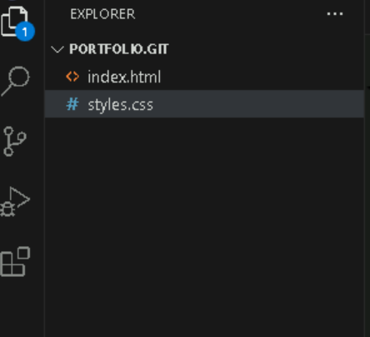

2.Designed the HTML Structure

* wrote the index.html file with sections: About me, Projects and Contacts.
* Used semantic HTML tags to structure the page.

Index.html

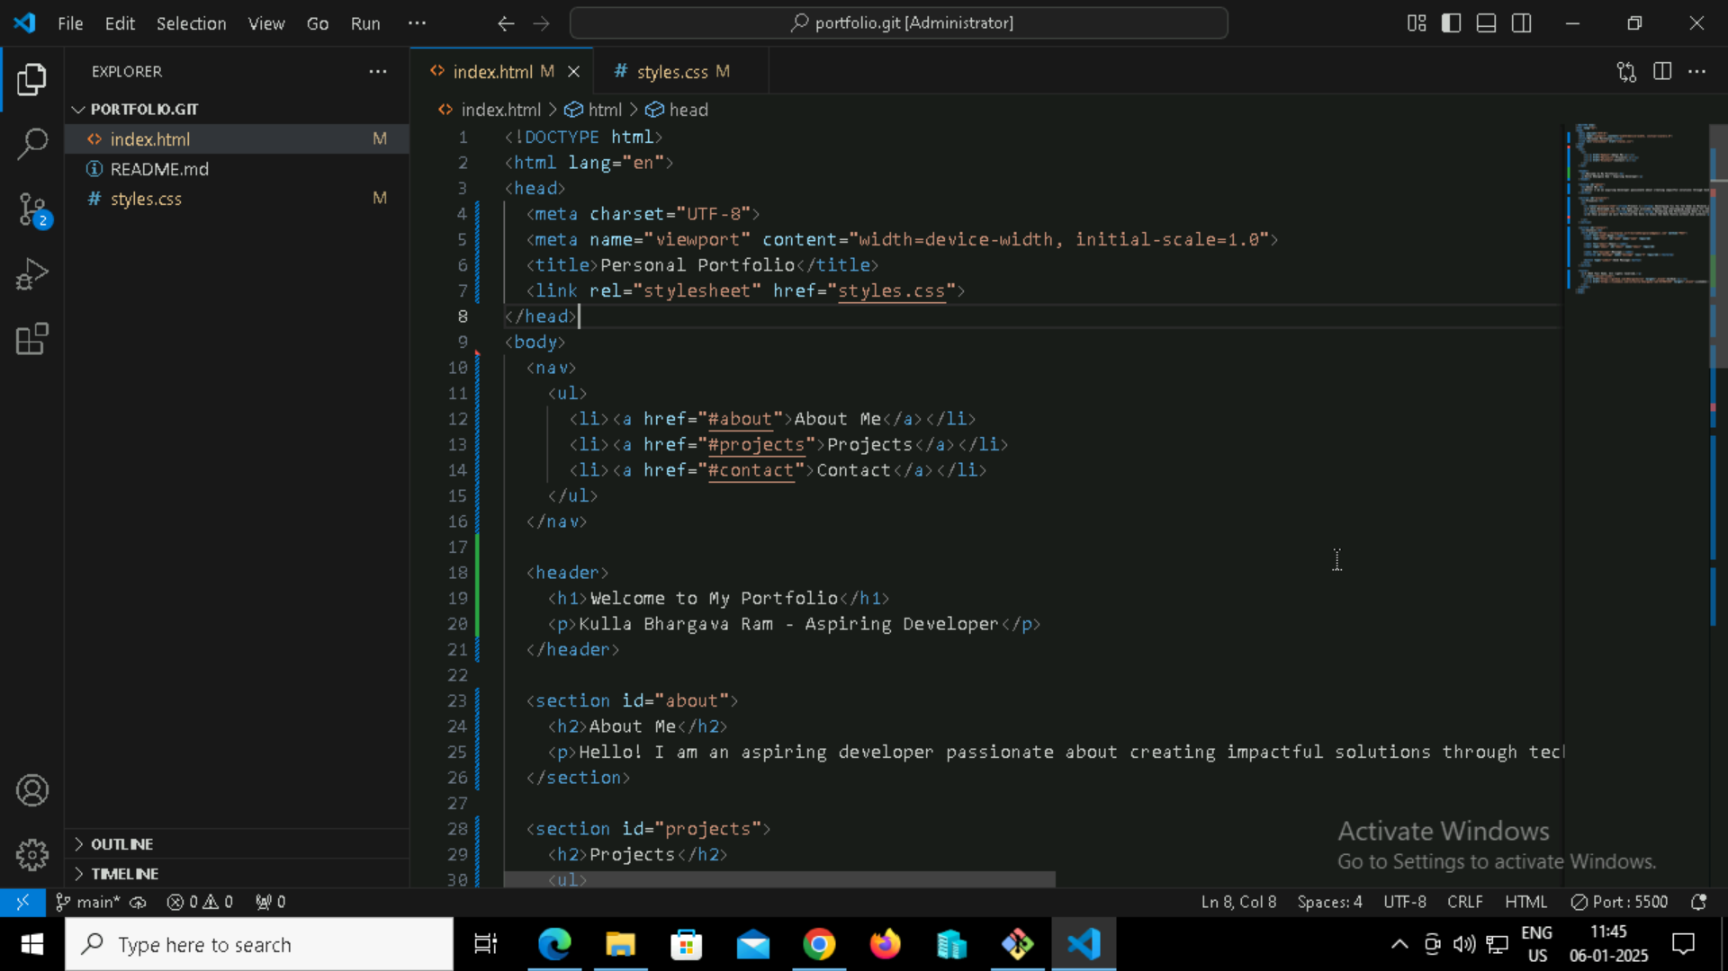

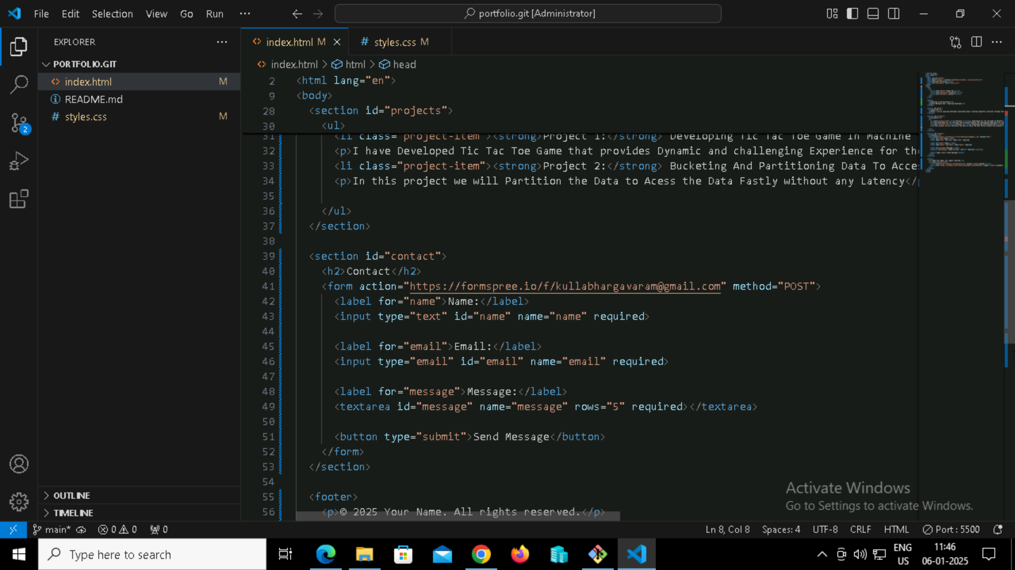

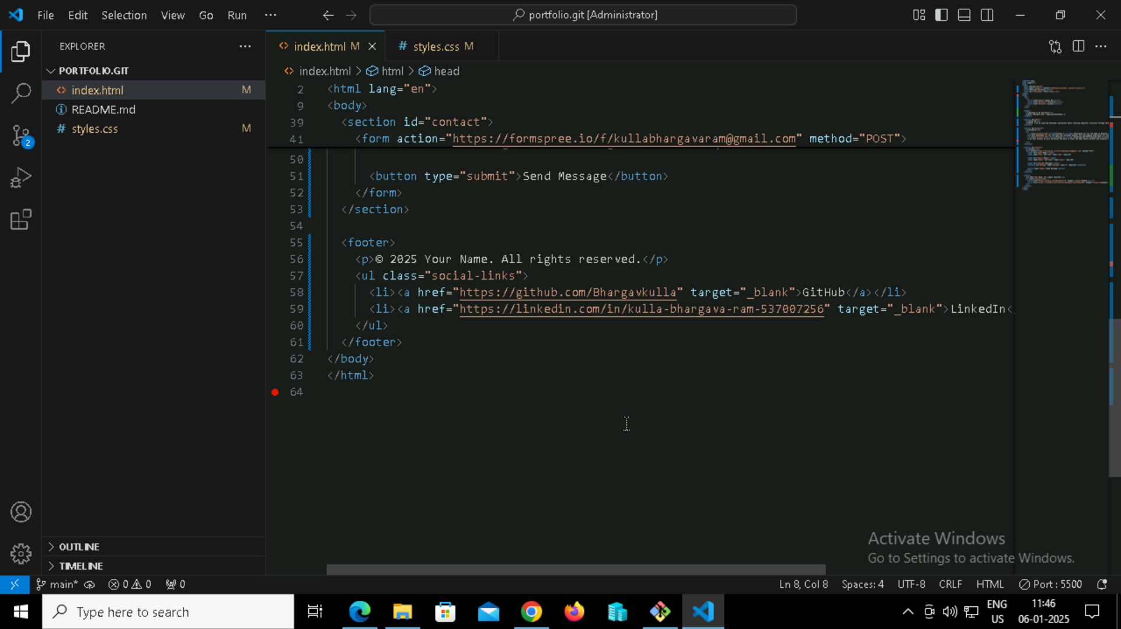

3.Styled the website using css

* Created the style.css file to add styles for the webpage.
* Styled the header, sections, project List, and Footer for a professional look.

Styles.css

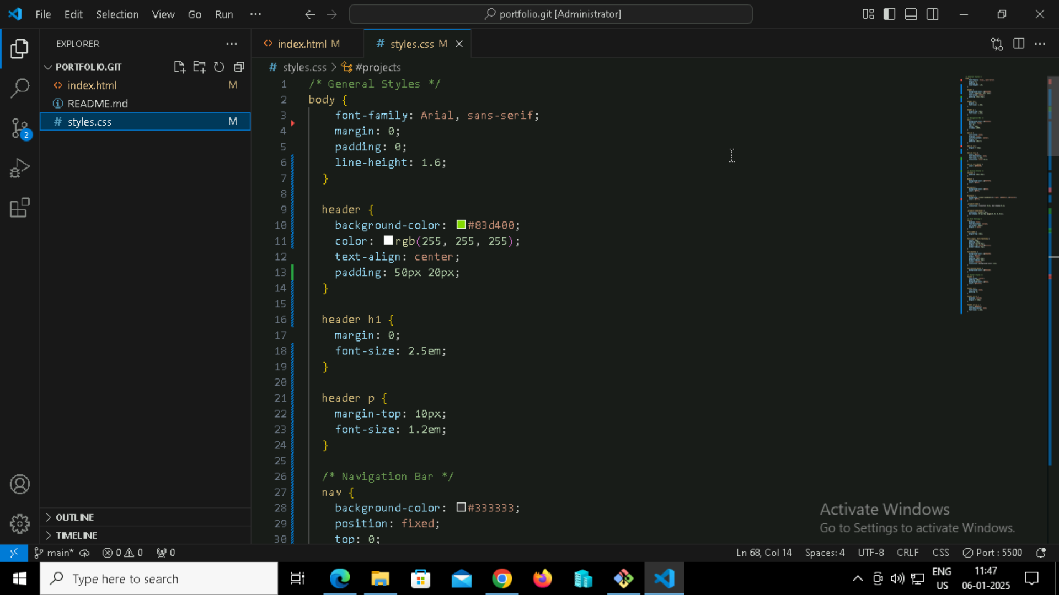

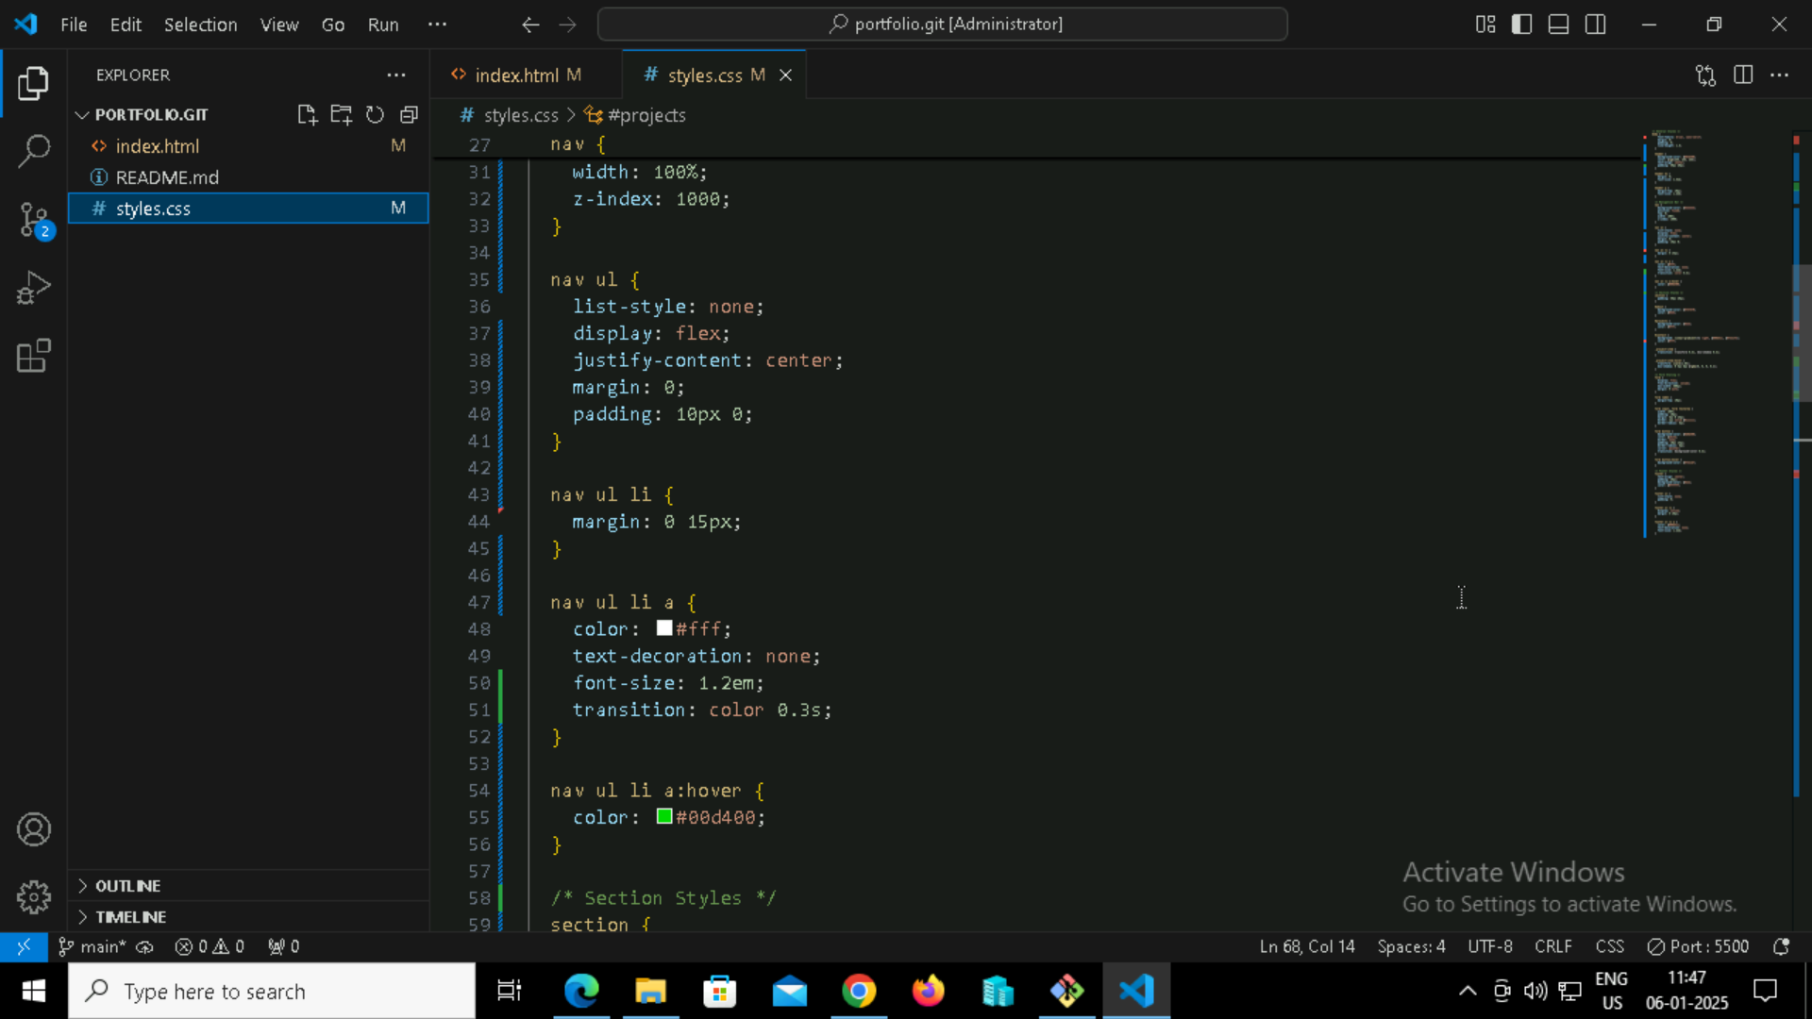

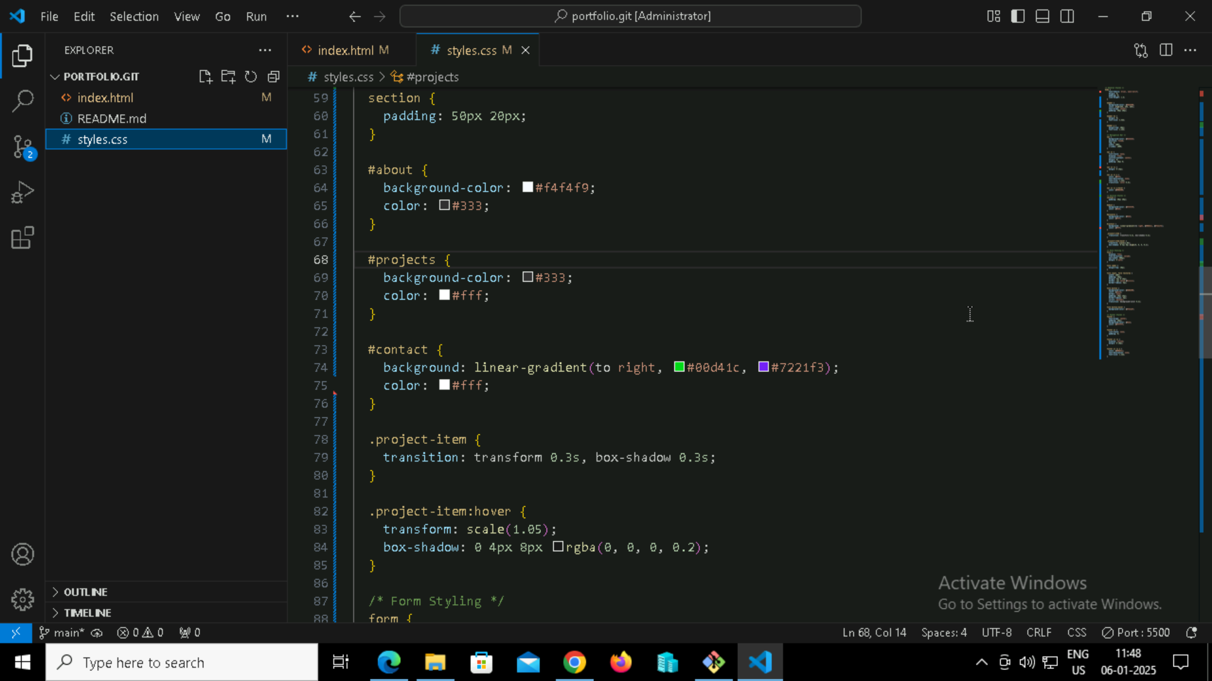

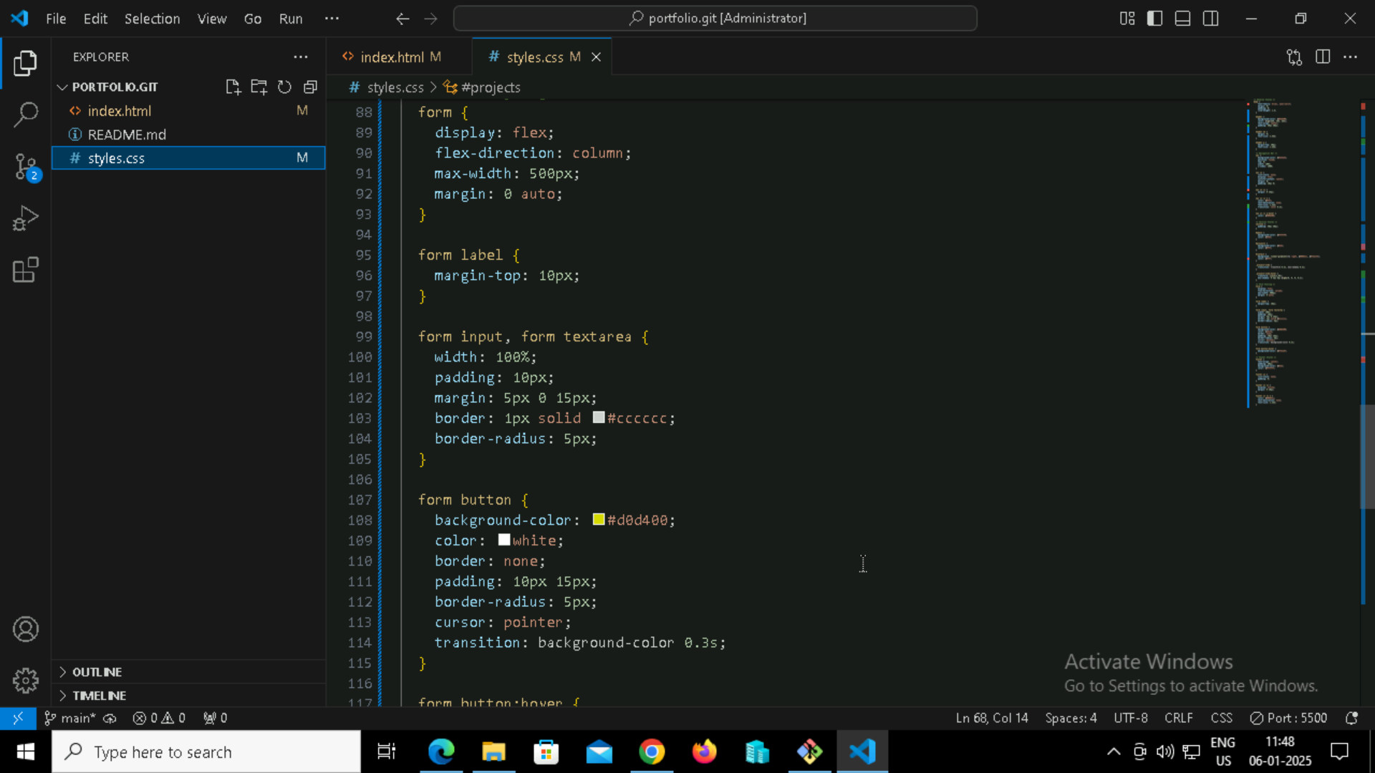

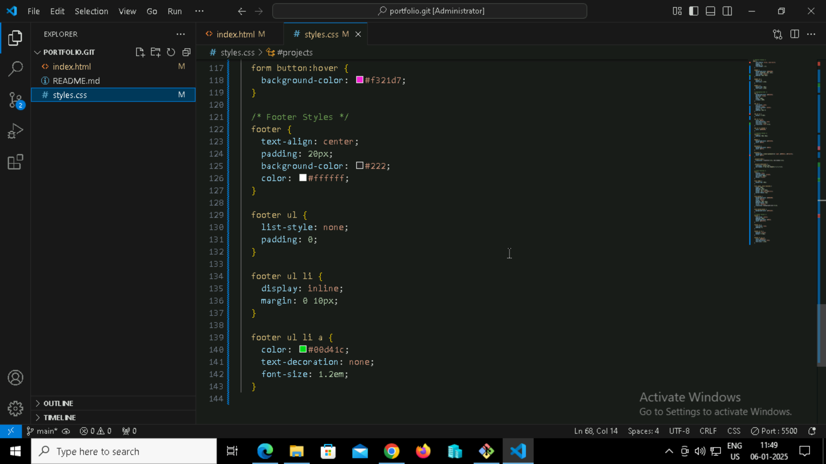

4. Previewed the Website Locally

* Opened the index.html file in a browser using VSCode's Live Server to check how it looks.
* Ensured the layout and styling matched the design plan.

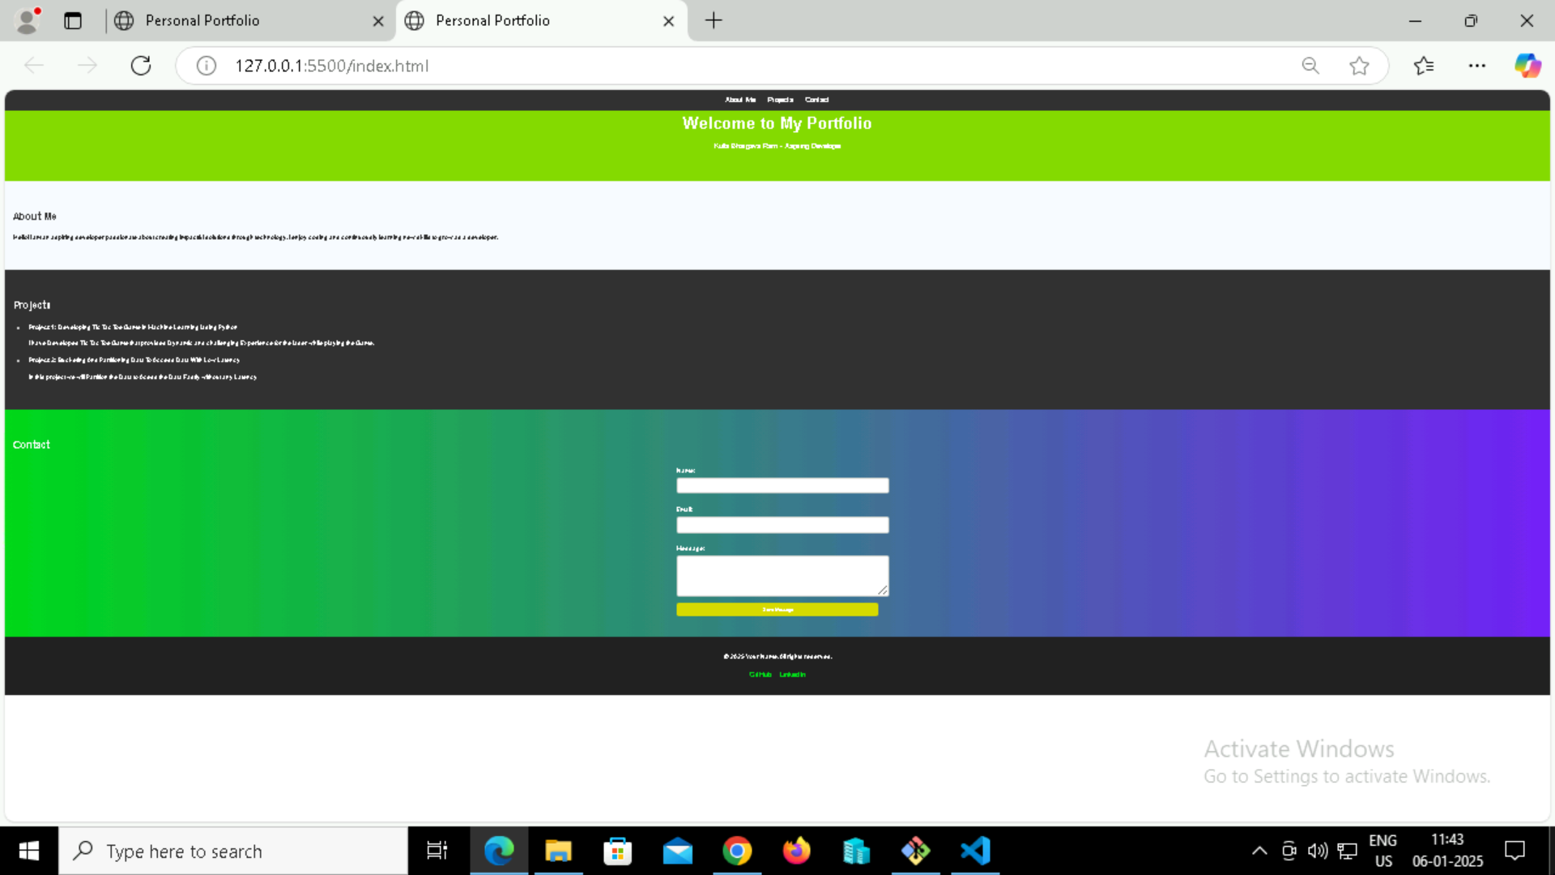

5. Initialized a Git Repository

* Opened the project folder in Git Bash.
* Ran the following command to initialize a Git repository:

git init

6. Added and Committed Files

* Staged all files using:

git add

* Committed the changes with an appropriate message:

git commit -m “files added”

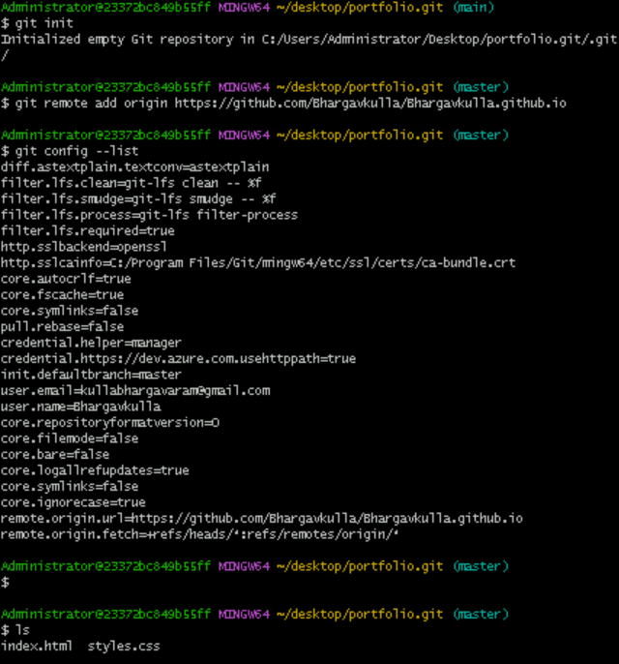

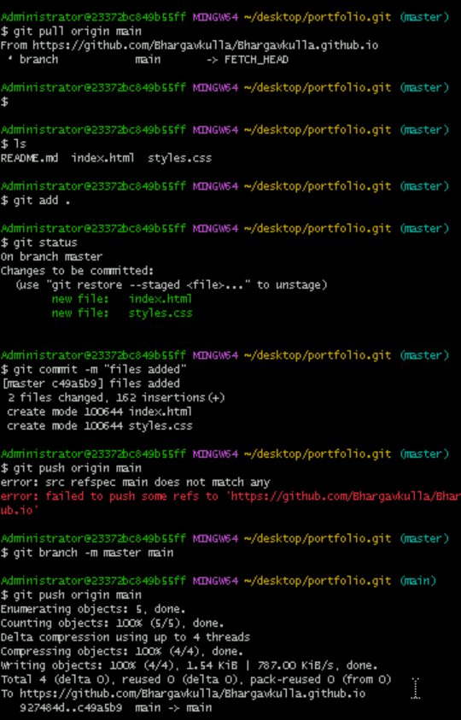

7. Created a GitHub Repository

* Created a new repository on GitHub named personal-portfolio.
* Copied the repository URL.

8. Linked Local Repository to GitHub

* Linked the local repository to GitHub using:

git remote add origin https://github.com/Bhargavkulla/Bhargavkulla.github.io

* Pushed the changes to GitHub:

git push origin main

